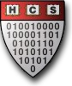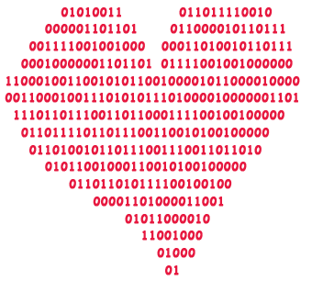

Presented by The Harvard University Computer Society

\* Nothing is binding, but why not take a chance on us…?

\*\* Undergrads are guaranteed to be matched with undergrads, and grads are guaranteed NOT to be matched with undergrads!

February 7th

Anyone with a Harvard email is

eligible for true love!\*\*

1. Sign up at datamatch.hcs.harvard.edu
2. Fill out our 30 question survey
3. Sit back and relax as we send you a list of top 10 matches\*

Finding your true love

is as easy as 1-2-3

Datamatch

Valentine’s